# **Computer and Tech Management System (CTMS)**

190041237 Tahmid Rahman

190041235 Protyoy Rafi

190041233 Md. Shoaib Shahriar Ibrahim

190041243 Sabry Said

//submission date: // 08-07-2021

// course teacher name Faisal Hussain, Tanjila Alam Sathi

**// Introduction**

This is a database management software that can be used to manage the necessary information regarding a computer hardware business.

**//Proposal**

The project aims to make a software which will allow the user to build a pc of their own choice as well as individual computer parts, also making it suitable for the shopkeepers to keep track of the products available, products to be sold and maintain the customer information.

**//Description**

When the user will run the software, a screen will appear showing the software name and a menu. Then there are two options for the user,

1. Buy individual parts of a PC

2. Build your PC

If the user chooses the first option, he will be asked for which computer part he wants to buy. When the user enters a choice, a list of the hardware that are in stock will be displayed. If the user asks for a product that is not in stock, it will display that the product is out of stock.

If the user goes for the second option, then he can build a full PC using the hardware of his choice from the given stock and calculate the total amount of money he needs to buy this PC.

After all the above things the user will be asked whether he would like to buy it! At the time of buying the user have to give some information about him which will be recorded for future references. If the total price exceeds a given price range, he will get some amount of discount based on that.

**//Features**

1. Allowing the user to build a virtual PC of own choice and showing the expected price.

2. Scope for the user to browse through the collection of computer parts and purchase any from the stock.

3. Easy user info and product info maintenance for the shopkeepers.

4. Discount based on total price of products.

**//UML diagram**

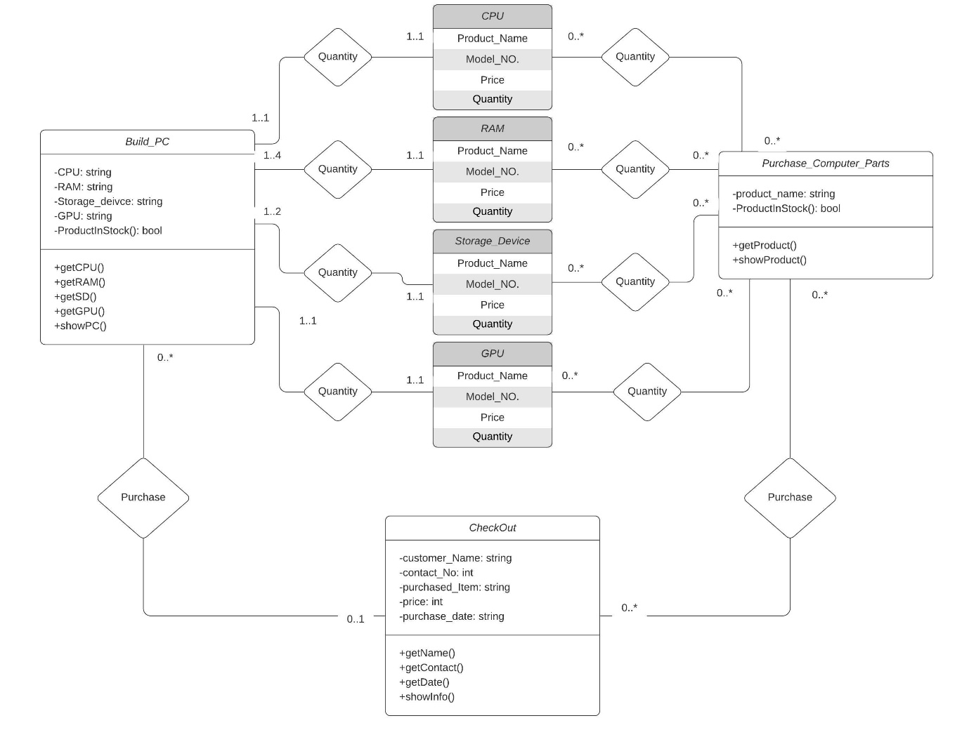

**//Conclusion**

Future planning regarding this project include:

1. Coupon system

2. Comparison between products

3. User account creation and management

4. Home delivery system